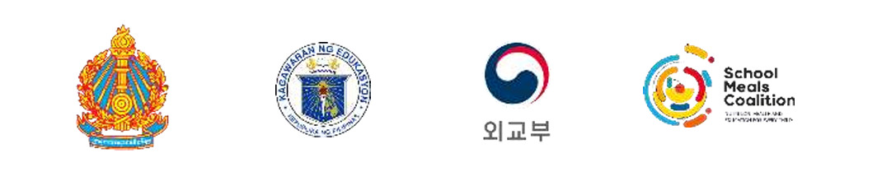

OUTCOME STATEMENT
On Southeast Asia School Meals Coalition Summit: Accelerating Collaboration and Commitment in Southeast Asian Countries to Advance Human Capital Development and Food Systems Transformation
The Member States of the School Meals Coalition from Southeast Asia including the Kingdom of Cambodia, Lao People’s Democratic Republic, the Republic of the Philippines, the Democratic Republic of Timor-Leste, together with representatives from Brunei Darussalam, the Republic of Korea and Singapore, and 39 stakeholders, gathered in Siem Reap from 18 to 20 November 2024 for the FIRST Southeast Asia School Meals Coalition Summit with the theme of “Accelerating Collaboration and Commitment in Southeast Asia Countries to Advance Human Capital Development and Food Systems Transformation.” This Southeast Asia School Meals Coalition Summit built on the School Meals Coalition Global Summit held in Paris in October 2023.
Key outcomes of the Summit:
- The Summit recognized that school meals are game-changing interventions that advance several interconnected Sustainable Development Goals. Home-Grown School Feeding Programmes have the potential to impact the nutrition of school aged children, support education, advance human capital, support local agriculture, promote social cohesion, improve health and hygiene education, reduce inequities, and provide long-term economic benefits.
- The Summit noted the current global needs for food system transformation to address the nutrition crisis, environmental degradation, biodiversity loss, and climate change—all of which threaten the well-being of school children. The Summit noted that school meal programmes need to be resilient to shocks like climate crises, which particularly affect the region, and economic pressures that governments face.
- Key evidence generation priorities were identified: Governments emphasized the need for robust national and regional evidence to guide effective policymaking, particularly on the school-aged children nutrition, health, and educational nexus. Evaluations, costing assessments, and return on investment studies fill evidence gaps, stimulate political will, and support advocacy.
- Policy Priorities were identified, with governments showcasing impressive progress on policy frameworks. Common priorities included an enhanced focus on policy implementation and localization. Coherent and integrated cross-sectoral policies are critical for school meal programme success. The voices of regional organizations, parliamentarians, and civil society organizations accelerate policy progress.
- Significant financial commitments to school meals have improved the coverage and quality of school meals. More investments are needed for school meal programmes to reach their full potential. Innovative sustainable financing mechanisms including blended and climate financing, offer opportunities to scale and sustain programmes.
- Stakeholders pushed for implementing nutrition standards in school meals through community engagement, behavior change, and measures like taxing unhealthy foods. Planet-friendly school meals through climate-smart agriculture, clean cooking and circular economy solutions can support food systems transformation.
- Countries agreed to sustain the momentum from the first Southeast Asia School Meals Coalition Summit. The Government of the Philippines announced their intention to host the next Asia School Meals Coalition Summit.

